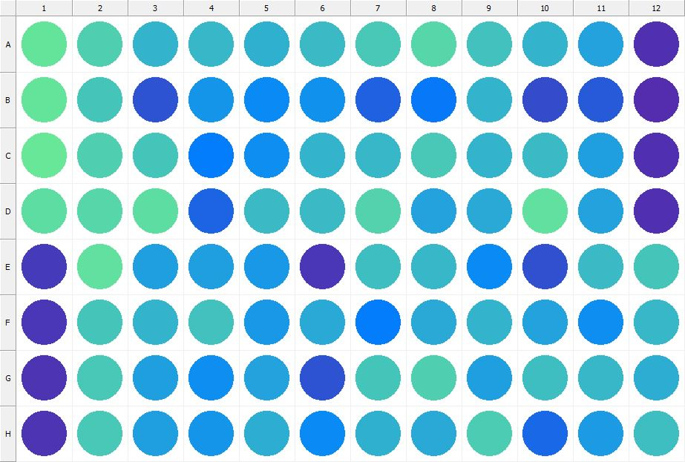

|  |
| --- |
| **Results for Tim_CTB(1) - channel 1 (RFU)** |

|  |  |  |  |  |  |  |  |  |  |  |  |  |
| --- | --- | --- | --- | --- | --- | --- | --- | --- | --- | --- | --- | --- |
|  | 01 | 02 | 03 | 04 | 05 | 06 | 07 | 08 | 09 | 10 | 11 | 12 |
| A | 153344 | 139587 | 120007 | 122635 | 118814 | 126212 | 133649 | 142805 | 128953 | 119916 | 109080 | 31683 |
| B | 152397 | 131883 | 56296 | 98781 | 93234 | 97735 | 64319 | 82006 | 121735 | 50249 | 61092 | 30483 |
| C | 156166 | 138231 | 131735 | 83309 | 94164 | 121082 | 123856 | 133517 | 121124 | 124356 | 107448 | 31698 |
| D | 147901 | 143945 | 147881 | 66337 | 124546 | 124701 | 142036 | 108383 | 113734 | 151554 | 108998 | 31560 |
| E | 38669 | 151283 | 106816 | 106648 | 100987 | 36689 | 127256 | 123610 | 92004 | 52779 | 126246 | 131148 |
| F | 36682 | 133136 | 121290 | 130577 | 102115 | 114202 | 84347 | 113965 | 121485 | 108262 | 94220 | 123966 |
| G | 34106 | 133956 | 105979 | 95848 | 108768 | 55360 | 131259 | 139968 | 106070 | 126693 | 123857 | 115946 |
| H | 34201 | 134027 | 106644 | 98850 | 117087 | 93323 | 117814 | 113504 | 136854 | 68842 | 103553 | 128032 |

|  |  |
| --- | --- |
| **Plate information** | |
|  | |
| **Plate** | 1 |
| **Repeat** | 1 |
| **Barcode** |  |
| **Measured height** | 14.78 |
| **Inside temperature at start** | 23.73 |
| **Inside temperature at end** | 23.75 |
| **Humidity at start** | 14.6 |
| **Humidity at end** | 14.8 |
| **Ambient temperature at start** | 23.64 |
| **Ambient temperature at end** | 23.66 |
| **Group** | 1 |
| **Label** | Tim_CTB(1) |
| **ScanX** | 0 |
| **ScanY** | 0 |
| **Measinfo** | De=1st Ex=Top Em=Top Wdw=N/A (14) |
| **Kinetics** | 0 |
| **Measurement date** | 11/21/2022 1:15:34 PM |
|  | |

|  |
| --- |
| **Background information** |
| Legend:  HDR1 - Plate  HDR2 - Label  HDR3 - Result  HDR4 - Signal  HDR5 - Flashes/Time  HDR6 - Meastime  HDR7 - MeasInfo |
| HDR1 HDR2 HDR3 HDR4 HDR5 HDR6 HDR7  1 Tim_CTB 0 1112 1 00:00:00.000 De=1st Ex=Top Em=Top Wdw=N/A (14) |
|  |

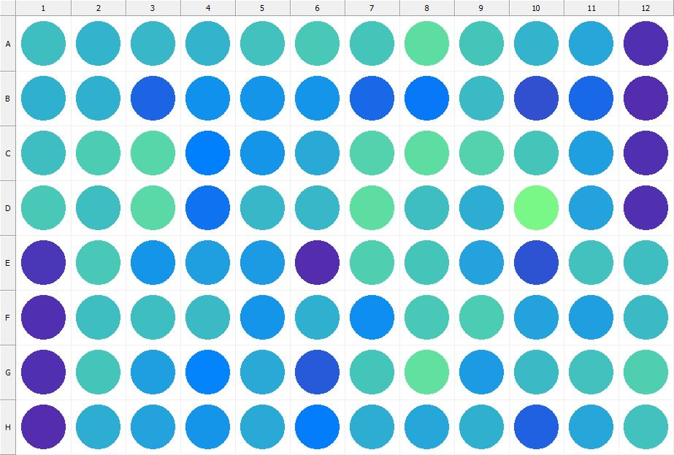

|  |
| --- |
| **Results for Tim_CTB(1) - channel 1 (RFU)** |

|  |  |  |  |  |  |  |  |  |  |  |  |  |
| --- | --- | --- | --- | --- | --- | --- | --- | --- | --- | --- | --- | --- |
|  | 01 | 02 | 03 | 04 | 05 | 06 | 07 | 08 | 09 | 10 | 11 | 12 |
| A | 128153 | 119923 | 122237 | 121456 | 130281 | 134991 | 133300 | 147998 | 132628 | 120228 | 112074 | 31825 |
| B | 117214 | 118778 | 66222 | 98464 | 98805 | 100881 | 69985 | 80226 | 124351 | 54409 | 69217 | 30860 |
| C | 127158 | 137656 | 143780 | 86347 | 98598 | 113240 | 142349 | 149608 | 141022 | 132433 | 106123 | 31702 |
| D | 134865 | 126493 | 145132 | 75969 | 123439 | 123557 | 147412 | 126557 | 115873 | 166653 | 109919 | 31604 |
| E | 37833 | 135474 | 99340 | 106444 | 103503 | 29764 | 139900 | 132691 | 108852 | 55221 | 129106 | 127915 |
| F | 33093 | 128095 | 128457 | 126060 | 100694 | 117194 | 94696 | 133778 | 137300 | 108412 | 105739 | 125767 |
| G | 33466 | 132000 | 106883 | 88450 | 114104 | 61036 | 132049 | 149660 | 104330 | 126202 | 129666 | 138047 |
| H | 30931 | 115353 | 109141 | 100270 | 112962 | 82705 | 115702 | 111730 | 119046 | 65563 | 110203 | 129464 |

|  |  |
| --- | --- |
| **Plate information** | |
|  | |
| **Plate** | 2 |
| **Repeat** | 1 |
| **Barcode** |  |
| **Measured height** | 14.78 |
| **Inside temperature at start** | 23.73 |
| **Inside temperature at end** | 23.73 |
| **Humidity at start** | 14.8 |
| **Humidity at end** | 14.8 |
| **Ambient temperature at start** | 23.73 |
| **Ambient temperature at end** | 23.64 |
| **Group** | 1 |
| **Label** | Tim_CTB(1) |
| **ScanX** | 0 |
| **ScanY** | 0 |
| **Measinfo** | De=1st Ex=Top Em=Top Wdw=N/A (14) |
| **Kinetics** | 0 |
| **Measurement date** | 11/21/2022 1:16:13 PM |
|  | |

|  |
| --- |
| **Background information** |
| Legend:  HDR1 - Plate  HDR2 - Label  HDR3 - Result  HDR4 - Signal  HDR5 - Flashes/Time  HDR6 - Meastime  HDR7 - MeasInfo |
| HDR1 HDR2 HDR3 HDR4 HDR5 HDR6 HDR7  2 Tim_CTB 0 981 1 00:00:00.000 De=1st Ex=Top Em=Top Wdw=N/A (14) |
|  |

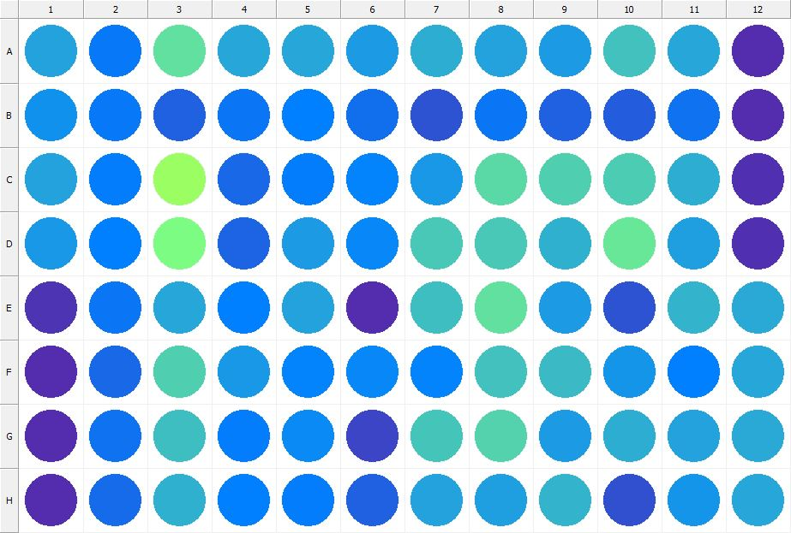

|  |
| --- |
| **Results for Tim_CTB(1) - channel 1 (RFU)** |

|  |  |  |  |  |  |  |  |  |  |  |  |  |
| --- | --- | --- | --- | --- | --- | --- | --- | --- | --- | --- | --- | --- |
|  | 01 | 02 | 03 | 04 | 05 | 06 | 07 | 08 | 09 | 10 | 11 | 12 |
| A | 109429 | 81851 | 150163 | 111998 | 110520 | 104572 | 115156 | 109973 | 103604 | 130721 | 112266 | 30983 |
| B | 97887 | 80920 | 66079 | 79753 | 86353 | 73761 | 55555 | 79027 | 65082 | 63289 | 75888 | 30568 |
| C | 108069 | 84238 | 189619 | 70545 | 84643 | 87926 | 101589 | 146083 | 138243 | 135707 | 114837 | 31543 |
| D | 102405 | 85880 | 169435 | 66533 | 105478 | 90807 | 135092 | 133637 | 118799 | 154670 | 106415 | 31323 |
| E | 34240 | 78314 | 111972 | 86740 | 109216 | 30747 | 127387 | 150868 | 103921 | 54754 | 121197 | 112894 |
| F | 30631 | 69075 | 139998 | 102866 | 88929 | 89997 | 87004 | 129494 | 125899 | 100101 | 86938 | 112361 |
| G | 30409 | 76147 | 127650 | 83606 | 92195 | 47073 | 131641 | 140489 | 104230 | 117005 | 107941 | 114784 |
| H | 29193 | 72540 | 118350 | 85457 | 83058 | 66007 | 108718 | 106374 | 119878 | 54300 | 98694 | 111226 |

|  |  |
| --- | --- |
| **Plate information** | |
|  | |
| **Plate** | 3 |
| **Repeat** | 1 |
| **Barcode** |  |
| **Measured height** | 14.78 |
| **Inside temperature at start** | 23.73 |
| **Inside temperature at end** | 23.73 |
| **Humidity at start** | 14.8 |
| **Humidity at end** | 14.8 |
| **Ambient temperature at start** | 23.64 |
| **Ambient temperature at end** | 23.54 |
| **Group** | 1 |
| **Label** | Tim_CTB(1) |
| **ScanX** | 0 |
| **ScanY** | 0 |
| **Measinfo** | De=1st Ex=Top Em=Top Wdw=N/A (14) |
| **Kinetics** | 0 |
| **Measurement date** | 11/21/2022 1:16:57 PM |
|  | |

|  |
| --- |
| **Background information** |
| Legend:  HDR1 - Plate  HDR2 - Label  HDR3 - Result  HDR4 - Signal  HDR5 - Flashes/Time  HDR6 - Meastime  HDR7 - MeasInfo |
| HDR1 HDR2 HDR3 HDR4 HDR5 HDR6 HDR7  3 Tim_CTB 0 1050 1 00:00:00.000 De=1st Ex=Top Em=Top Wdw=N/A (14) |
|  |

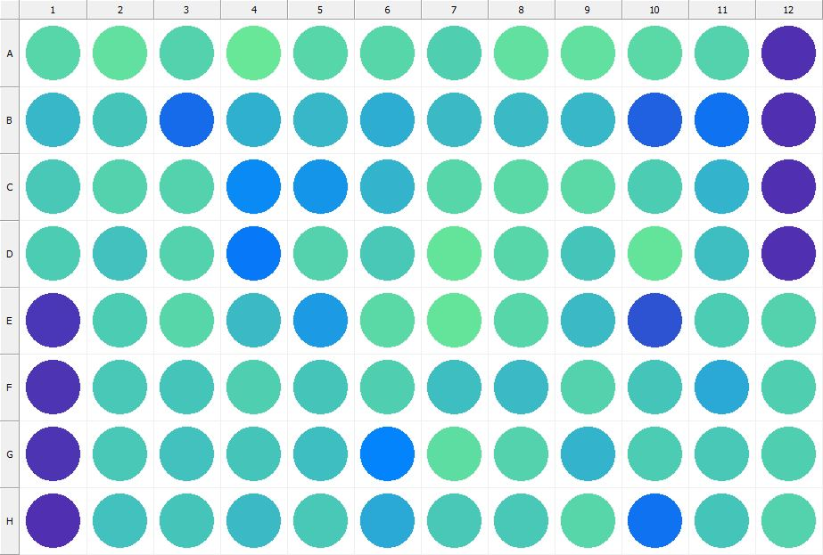

|  |
| --- |
| **Results for Tim_CTB(1) - channel 1 (RFU)** |

|  |  |  |  |  |  |  |  |  |  |  |  |  |
| --- | --- | --- | --- | --- | --- | --- | --- | --- | --- | --- | --- | --- |
|  | 01 | 02 | 03 | 04 | 05 | 06 | 07 | 08 | 09 | 10 | 11 | 12 |
| A | 144646 | 151753 | 141046 | 155197 | 144338 | 143660 | 140138 | 150244 | 150244 | 145198 | 140603 | 33228 |
| B | 123664 | 132508 | 70994 | 119439 | 121857 | 116424 | 126349 | 126179 | 123259 | 64142 | 76860 | 31467 |
| C | 135513 | 140710 | 141058 | 93903 | 99456 | 120321 | 143449 | 147001 | 146981 | 136078 | 120041 | 32681 |
| D | 136442 | 129207 | 141872 | 81271 | 140701 | 134167 | 153205 | 143718 | 133016 | 153445 | 127368 | 33379 |
| E | 38016 | 136005 | 143214 | 125421 | 103919 | 145746 | 151938 | 143334 | 125407 | 55923 | 137692 | 141041 |
| F | 34892 | 134443 | 132460 | 139610 | 132287 | 138516 | 126757 | 124856 | 142118 | 131731 | 112737 | 139610 |
| G | 34955 | 135613 | 130004 | 132556 | 127297 | 88318 | 147356 | 142615 | 120637 | 136011 | 135408 | 138206 |
| H | 31724 | 130873 | 132485 | 124780 | 135038 | 113505 | 133666 | 134448 | 144093 | 77068 | 132407 | 140681 |

|  |  |
| --- | --- |
| **Plate information** | |
|  | |
| **Plate** | 4 |
| **Repeat** | 1 |
| **Barcode** |  |
| **Measured height** | 14.78 |
| **Inside temperature at start** | 23.73 |
| **Inside temperature at end** | 23.73 |
| **Humidity at start** | 14.8 |
| **Humidity at end** | 14.8 |
| **Ambient temperature at start** | 23.44 |
| **Ambient temperature at end** | 23.34 |
| **Group** | 1 |
| **Label** | Tim_CTB(1) |
| **ScanX** | 0 |
| **ScanY** | 0 |
| **Measinfo** | De=1st Ex=Top Em=Top Wdw=N/A (14) |
| **Kinetics** | 0 |
| **Measurement date** | 11/21/2022 1:17:40 PM |
|  | |

|  |
| --- |
| **Background information** |
| Legend:  HDR1 - Plate  HDR2 - Label  HDR3 - Result  HDR4 - Signal  HDR5 - Flashes/Time  HDR6 - Meastime  HDR7 - MeasInfo |
| HDR1 HDR2 HDR3 HDR4 HDR5 HDR6 HDR7  4 Tim_CTB 0 1091 1 00:00:00.000 De=1st Ex=Top Em=Top Wdw=N/A (14) |
|  |

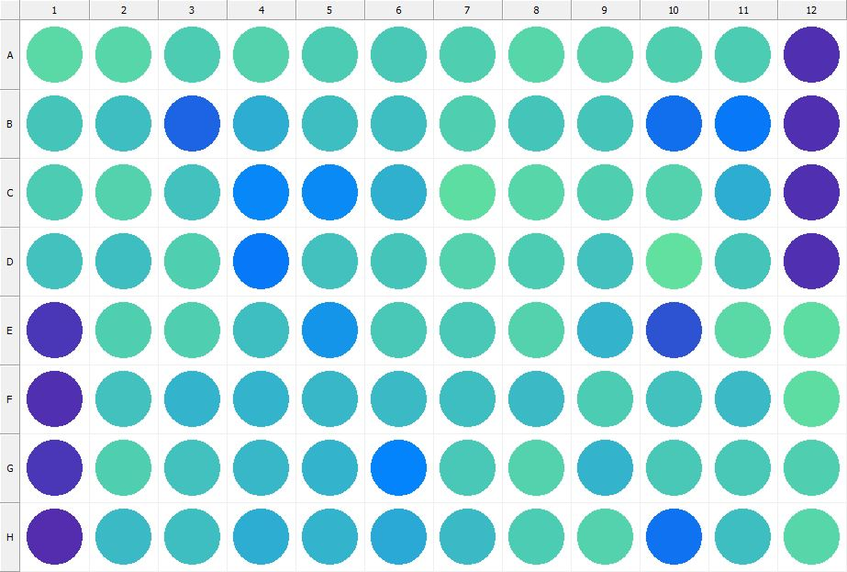

|  |
| --- |
| **Results for Tim_CTB(1) - channel 1 (RFU)** |

|  |  |  |  |  |  |  |  |  |  |  |  |  |
| --- | --- | --- | --- | --- | --- | --- | --- | --- | --- | --- | --- | --- |
|  | 01 | 02 | 03 | 04 | 05 | 06 | 07 | 08 | 09 | 10 | 11 | 12 |
| A | 146133 | 143046 | 137160 | 142240 | 137906 | 134646 | 138292 | 142843 | 142099 | 138779 | 136775 | 32816 |
| B | 131078 | 128712 | 67073 | 115432 | 127728 | 127580 | 138766 | 132690 | 131743 | 75089 | 80674 | 31457 |
| C | 135800 | 140891 | 129553 | 89649 | 93370 | 118984 | 149075 | 143810 | 138302 | 141105 | 116193 | 32953 |
| D | 129122 | 127317 | 138460 | 82185 | 129612 | 131876 | 142558 | 137112 | 129444 | 151721 | 131891 | 32897 |
| E | 36938 | 138199 | 140239 | 126925 | 99680 | 134629 | 134413 | 142513 | 121523 | 54941 | 146804 | 148651 |
| F | 32791 | 129761 | 120800 | 120214 | 121793 | 125247 | 128443 | 124303 | 137580 | 129058 | 124164 | 149053 |
| G | 36342 | 138787 | 128879 | 122322 | 120120 | 88118 | 135306 | 140468 | 121299 | 134431 | 134024 | 138052 |
| H | 30801 | 124983 | 128610 | 116732 | 120566 | 113932 | 125336 | 137410 | 141526 | 77676 | 127381 | 142686 |

|  |  |
| --- | --- |
| **Plate information** | |
|  | |
| **Plate** | 5 |
| **Repeat** | 1 |
| **Barcode** |  |
| **Measured height** | 14.78 |
| **Inside temperature at start** | 23.73 |
| **Inside temperature at end** | 23.75 |
| **Humidity at start** | 14.8 |
| **Humidity at end** | 14.8 |
| **Ambient temperature at start** | 23.34 |
| **Ambient temperature at end** | 23.36 |
| **Group** | 1 |
| **Label** | Tim_CTB(1) |
| **ScanX** | 0 |
| **ScanY** | 0 |
| **Measinfo** | De=1st Ex=Top Em=Top Wdw=N/A (14) |
| **Kinetics** | 0 |
| **Measurement date** | 11/21/2022 1:18:21 PM |
|  | |

|  |
| --- |
| **Background information** |
| Legend:  HDR1 - Plate  HDR2 - Label  HDR3 - Result  HDR4 - Signal  HDR5 - Flashes/Time  HDR6 - Meastime  HDR7 - MeasInfo |
| HDR1 HDR2 HDR3 HDR4 HDR5 HDR6 HDR7  5 Tim_CTB 0 1128 1 00:00:00.000 De=1st Ex=Top Em=Top Wdw=N/A (14) |
|  |

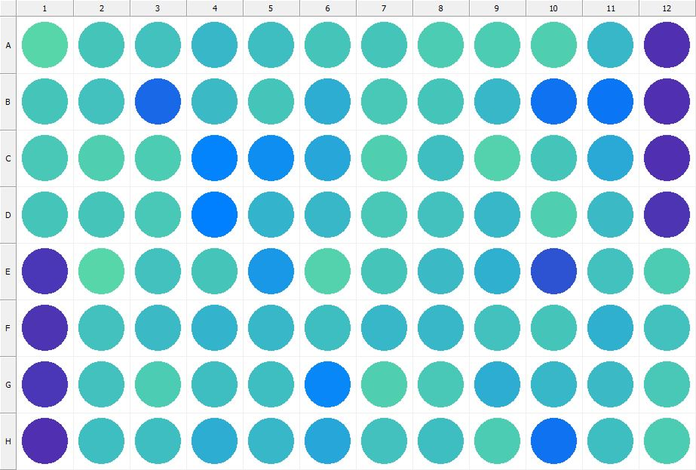

|  |
| --- |
| **Results for Tim_CTB(1) - channel 1 (RFU)** |

|  |  |  |  |  |  |  |  |  |  |  |  |  |
| --- | --- | --- | --- | --- | --- | --- | --- | --- | --- | --- | --- | --- |
|  | 01 | 02 | 03 | 04 | 05 | 06 | 07 | 08 | 09 | 10 | 11 | 12 |
| A | 143567 | 132433 | 130393 | 123299 | 128486 | 131698 | 133196 | 137045 | 136766 | 140296 | 123721 | 32950 |
| B | 131245 | 130902 | 70007 | 125227 | 133250 | 115266 | 133731 | 132347 | 121992 | 76308 | 79526 | 31639 |
| C | 133947 | 139454 | 135862 | 88892 | 95837 | 111494 | 139066 | 128234 | 142264 | 131920 | 113231 | 32667 |
| D | 131644 | 132809 | 134844 | 85288 | 121344 | 122572 | 134756 | 130225 | 122550 | 138481 | 125212 | 33969 |
| E | 37257 | 143207 | 129597 | 131190 | 102725 | 140689 | 133252 | 125600 | 119194 | 56730 | 130568 | 136840 |
| F | 33657 | 129661 | 124727 | 119810 | 123486 | 127097 | 123481 | 122855 | 130233 | 131534 | 118968 | 130228 |
| G | 38047 | 129884 | 136442 | 126985 | 126470 | 89328 | 140285 | 134193 | 116166 | 123871 | 124518 | 133567 |
| H | 31887 | 127574 | 127949 | 116039 | 122810 | 111641 | 129859 | 127254 | 136857 | 77393 | 126703 | 135870 |

|  |  |
| --- | --- |
| **Plate information** | |
|  | |
| **Plate** | 6 |
| **Repeat** | 1 |
| **Barcode** |  |
| **Measured height** | 14.78 |
| **Inside temperature at start** | 23.73 |
| **Inside temperature at end** | 23.73 |
| **Humidity at start** | 14.8 |
| **Humidity at end** | 14.8 |
| **Ambient temperature at start** | 23.34 |
| **Ambient temperature at end** | 23.34 |
| **Group** | 1 |
| **Label** | Tim_CTB(1) |
| **ScanX** | 0 |
| **ScanY** | 0 |
| **Measinfo** | De=1st Ex=Top Em=Top Wdw=N/A (14) |
| **Kinetics** | 0 |
| **Measurement date** | 11/21/2022 1:19:05 PM |
|  | |

|  |
| --- |
| **Background information** |
| Legend:  HDR1 - Plate  HDR2 - Label  HDR3 - Result  HDR4 - Signal  HDR5 - Flashes/Time  HDR6 - Meastime  HDR7 - MeasInfo |
| HDR1 HDR2 HDR3 HDR4 HDR5 HDR6 HDR7  6 Tim_CTB 0 1129 1 00:00:00.000 De=1st Ex=Top Em=Top Wdw=N/A (14) |
|  |

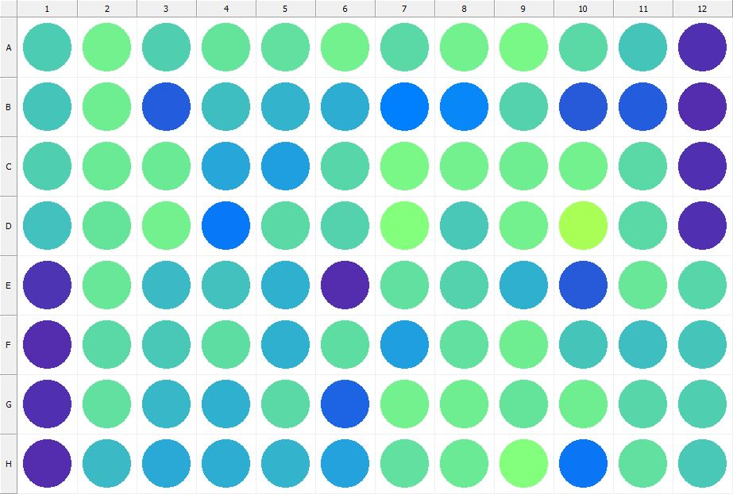

|  |
| --- |
| **Results for Tim_CTB(1) - channel 1 (RFU)** |

|  |  |  |  |  |  |  |  |  |  |  |  |  |
| --- | --- | --- | --- | --- | --- | --- | --- | --- | --- | --- | --- | --- |
|  | 01 | 02 | 03 | 04 | 05 | 06 | 07 | 08 | 09 | 10 | 11 | 12 |
| A | 135737 | 162241 | 139555 | 152447 | 150353 | 162993 | 147141 | 161300 | 166555 | 146347 | 131747 | 31943 |
| B | 132360 | 159329 | 63293 | 128542 | 119723 | 116675 | 85474 | 89350 | 141118 | 60775 | 62594 | 30621 |
| C | 138826 | 156946 | 158753 | 110562 | 107028 | 143008 | 167699 | 161897 | 159645 | 162421 | 145474 | 32580 |
| D | 130816 | 153044 | 161275 | 81810 | 147113 | 141273 | 173524 | 134259 | 162046 | 200193 | 147064 | 32110 |
| E | 34345 | 155883 | 125970 | 130089 | 118616 | 30782 | 150476 | 141140 | 118751 | 60532 | 155803 | 143455 |
| F | 31103 | 146048 | 133594 | 149224 | 119190 | 148708 | 105709 | 149769 | 160682 | 131458 | 128383 | 132969 |
| G | 31429 | 149818 | 122730 | 117599 | 146651 | 67160 | 161492 | 159498 | 153772 | 160379 | 144318 | 139290 |
| H | 29639 | 125393 | 112739 | 115443 | 120302 | 108184 | 150424 | 158002 | 173420 | 79094 | 150555 | 135675 |

|  |  |
| --- | --- |
| **Plate information** | |
|  | |
| **Plate** | 7 |
| **Repeat** | 1 |
| **Barcode** |  |
| **Measured height** | 14.78 |
| **Inside temperature at start** | 23.83 |
| **Inside temperature at end** | 23.83 |
| **Humidity at start** | 14.6 |
| **Humidity at end** | 14.6 |
| **Ambient temperature at start** | 23.54 |
| **Ambient temperature at end** | 23.64 |
| **Group** | 1 |
| **Label** | Tim_CTB(1) |
| **ScanX** | 0 |
| **ScanY** | 0 |
| **Measinfo** | De=1st Ex=Top Em=Top Wdw=N/A (14) |
| **Kinetics** | 0 |
| **Measurement date** | 11/21/2022 1:19:48 PM |
|  | |

|  |
| --- |
| **Background information** |
| Legend:  HDR1 - Plate  HDR2 - Label  HDR3 - Result  HDR4 - Signal  HDR5 - Flashes/Time  HDR6 - Meastime  HDR7 - MeasInfo |
| HDR1 HDR2 HDR3 HDR4 HDR5 HDR6 HDR7  7 Tim_CTB 0 1074 1 00:00:00.000 De=1st Ex=Top Em=Top Wdw=N/A (14) |
|  |

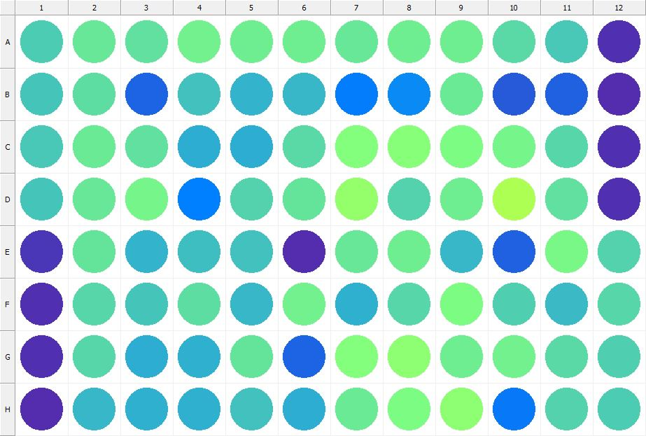

|  |
| --- |
| **Results for Tim_CTB(1) - channel 1 (RFU)** |

|  |  |  |  |  |  |  |  |  |  |  |  |  |
| --- | --- | --- | --- | --- | --- | --- | --- | --- | --- | --- | --- | --- |
|  | 01 | 02 | 03 | 04 | 05 | 06 | 07 | 08 | 09 | 10 | 11 | 12 |
| A | 136483 | 155988 | 150957 | 162629 | 159190 | 160737 | 155649 | 160852 | 160969 | 146957 | 135379 | 31765 |
| B | 133159 | 148696 | 66367 | 129067 | 119681 | 122182 | 83981 | 91892 | 157276 | 60651 | 65367 | 30993 |
| C | 134022 | 156788 | 150544 | 115838 | 115894 | 146289 | 174743 | 177051 | 170144 | 165359 | 144560 | 31714 |
| D | 132132 | 155847 | 164957 | 85353 | 142056 | 153929 | 185272 | 141225 | 159900 | 201471 | 150328 | 32396 |
| E | 36607 | 153396 | 121145 | 127186 | 129107 | 30609 | 154542 | 159726 | 123725 | 63848 | 167540 | 140503 |
| F | 32312 | 144626 | 131774 | 148664 | 123392 | 163255 | 118076 | 143931 | 168881 | 138094 | 124804 | 144552 |
| G | 32653 | 144395 | 114825 | 118142 | 152642 | 66870 | 175019 | 180496 | 160831 | 163124 | 146375 | 140140 |
| H | 30809 | 122145 | 118635 | 118539 | 130114 | 115740 | 158231 | 170123 | 180767 | 81949 | 140382 | 136270 |

|  |  |
| --- | --- |
| **Plate information** | |
|  | |
| **Plate** | 8 |
| **Repeat** | 1 |
| **Barcode** |  |
| **Measured height** | 14.78 |
| **Inside temperature at start** | 23.83 |
| **Inside temperature at end** | 23.85 |
| **Humidity at start** | 14.4 |
| **Humidity at end** | 14.6 |
| **Ambient temperature at start** | 23.44 |
| **Ambient temperature at end** | 23.46 |
| **Group** | 1 |
| **Label** | Tim_CTB(1) |
| **ScanX** | 0 |
| **ScanY** | 0 |
| **Measinfo** | De=1st Ex=Top Em=Top Wdw=N/A (14) |
| **Kinetics** | 0 |
| **Measurement date** | 11/21/2022 1:20:47 PM |
|  | |

|  |
| --- |
| **Background information** |
| Legend:  HDR1 - Plate  HDR2 - Label  HDR3 - Result  HDR4 - Signal  HDR5 - Flashes/Time  HDR6 - Meastime  HDR7 - MeasInfo |
| HDR1 HDR2 HDR3 HDR4 HDR5 HDR6 HDR7  8 Tim_CTB 0 1064 1 00:00:00.000 De=1st Ex=Top Em=Top Wdw=N/A (14) |
|  |

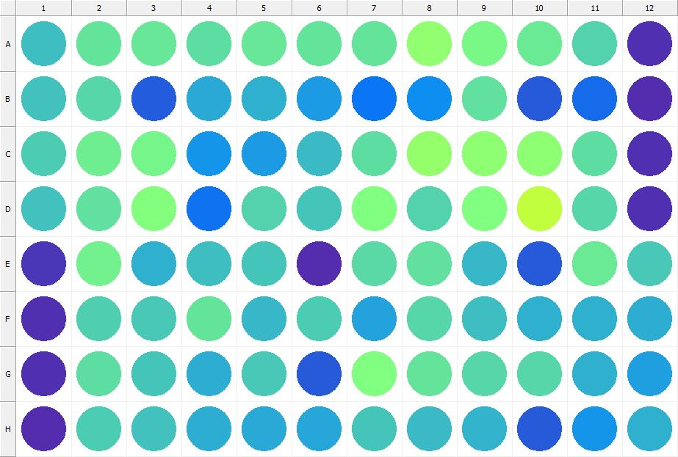

|  |
| --- |
| **Results for Tim_CTB(1) - channel 1 (RFU)** |

|  |  |  |  |  |  |  |  |  |  |  |  |  |
| --- | --- | --- | --- | --- | --- | --- | --- | --- | --- | --- | --- | --- |
|  | 01 | 02 | 03 | 04 | 05 | 06 | 07 | 08 | 09 | 10 | 11 | 12 |
| A | 126701 | 153302 | 155834 | 147819 | 156097 | 152016 | 154107 | 183742 | 166961 | 156799 | 141124 | 31766 |
| B | 130204 | 143036 | 63032 | 114759 | 117839 | 104793 | 79421 | 93990 | 150014 | 60506 | 71115 | 30644 |
| C | 137917 | 160457 | 164690 | 99890 | 103958 | 125109 | 149316 | 185217 | 180213 | 181030 | 149384 | 32655 |
| D | 130116 | 149745 | 173661 | 76705 | 141987 | 133233 | 171102 | 142347 | 170879 | 215286 | 144090 | 32190 |
| E | 37842 | 162129 | 119382 | 128567 | 131394 | 29581 | 146534 | 151757 | 122956 | 60106 | 157200 | 133815 |
| F | 32914 | 139947 | 135664 | 154134 | 122872 | 137342 | 109457 | 144253 | 128255 | 117836 | 117527 | 115168 |
| G | 32484 | 148909 | 132787 | 116891 | 133607 | 60257 | 170658 | 153288 | 142688 | 143645 | 117852 | 106768 |
| H | 30402 | 137148 | 129054 | 115565 | 112826 | 110624 | 131332 | 124628 | 121505 | 60323 | 100174 | 117331 |

|  |  |
| --- | --- |
| **Plate information** | |
|  | |
| **Plate** | 9 |
| **Repeat** | 1 |
| **Barcode** |  |
| **Measured height** | 14.78 |
| **Inside temperature at start** | 23.83 |
| **Inside temperature at end** | 23.75 |
| **Humidity at start** | 14.8 |
| **Humidity at end** | 14.8 |
| **Ambient temperature at start** | 23.64 |
| **Ambient temperature at end** | 23.56 |
| **Group** | 1 |
| **Label** | Tim_CTB(1) |
| **ScanX** | 0 |
| **ScanY** | 0 |
| **Measinfo** | De=1st Ex=Top Em=Top Wdw=N/A (14) |
| **Kinetics** | 0 |
| **Measurement date** | 11/21/2022 1:21:28 PM |
|  | |

|  |
| --- |
| **Background information** |
| Legend:  HDR1 - Plate  HDR2 - Label  HDR3 - Result  HDR4 - Signal  HDR5 - Flashes/Time  HDR6 - Meastime  HDR7 - MeasInfo |
| HDR1 HDR2 HDR3 HDR4 HDR5 HDR6 HDR7  9 Tim_CTB 0 1072 1 00:00:00.000 De=1st Ex=Top Em=Top Wdw=N/A (14) |
|  |

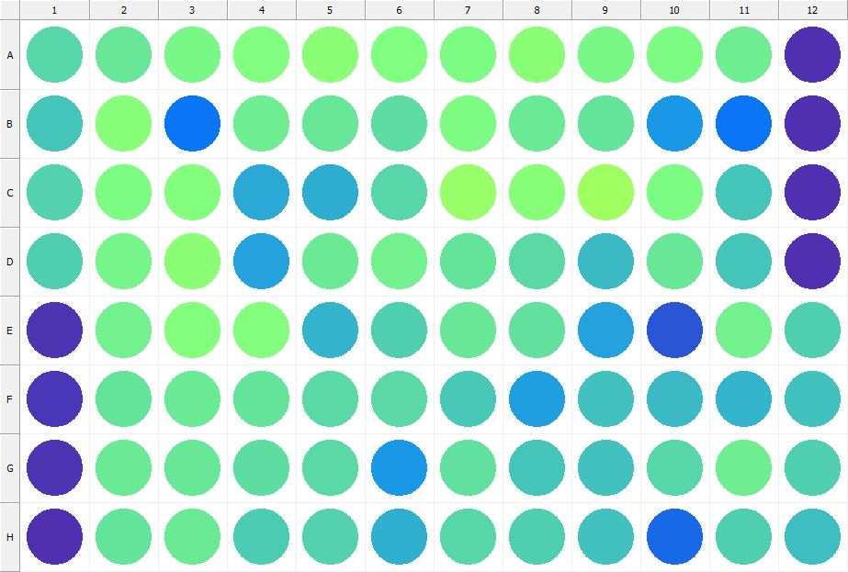

|  |
| --- |
| **Results for Tim_CTB(1) - channel 1 (RFU)** |

|  |  |  |  |  |  |  |  |  |  |  |  |  |
| --- | --- | --- | --- | --- | --- | --- | --- | --- | --- | --- | --- | --- |
|  | 01 | 02 | 03 | 04 | 05 | 06 | 07 | 08 | 09 | 10 | 11 | 12 |
| A | 143552 | 154910 | 166896 | 170999 | 178030 | 172528 | 169560 | 177962 | 167258 | 170324 | 159891 | 32818 |
| B | 132221 | 175389 | 78676 | 160392 | 155283 | 148543 | 169594 | 158612 | 152452 | 102481 | 78892 | 31534 |
| C | 141850 | 169817 | 173601 | 113037 | 115331 | 144136 | 188309 | 175650 | 192032 | 170271 | 132838 | 31912 |
| D | 139698 | 165285 | 179536 | 109541 | 156688 | 162231 | 153431 | 145589 | 126347 | 154841 | 131543 | 32604 |
| E | 35547 | 161866 | 174745 | 173390 | 120682 | 139468 | 154417 | 149841 | 108852 | 57543 | 162728 | 139781 |
| F | 37411 | 153963 | 158168 | 154121 | 147231 | 146881 | 134241 | 105560 | 129137 | 124549 | 119851 | 129575 |
| G | 34856 | 158341 | 154925 | 147899 | 146833 | 103201 | 150187 | 131482 | 130471 | 142875 | 161098 | 138278 |
| H | 31367 | 153842 | 158643 | 137799 | 141717 | 119181 | 144747 | 138429 | 130968 | 68741 | 138160 | 128177 |

|  |  |
| --- | --- |
| **Plate information** | |
|  | |
| **Plate** | 10 |
| **Repeat** | 1 |
| **Barcode** |  |
| **Measured height** | 14.78 |
| **Inside temperature at start** | 23.83 |
| **Inside temperature at end** | 23.85 |
| **Humidity at start** | 14.6 |
| **Humidity at end** | 14.8 |
| **Ambient temperature at start** | 23.54 |
| **Ambient temperature at end** | 23.66 |
| **Group** | 1 |
| **Label** | Tim_CTB(1) |
| **ScanX** | 0 |
| **ScanY** | 0 |
| **Measinfo** | De=1st Ex=Top Em=Top Wdw=N/A (14) |
| **Kinetics** | 0 |
| **Measurement date** | 11/21/2022 1:22:08 PM |
|  | |

|  |
| --- |
| **Background information** |
| Legend:  HDR1 - Plate  HDR2 - Label  HDR3 - Result  HDR4 - Signal  HDR5 - Flashes/Time  HDR6 - Meastime  HDR7 - MeasInfo |
| HDR1 HDR2 HDR3 HDR4 HDR5 HDR6 HDR7  10 Tim_CTB 0 1081 1 00:00:00.000 De=1st Ex=Top Em=Top Wdw=N/A (14) |
|  |

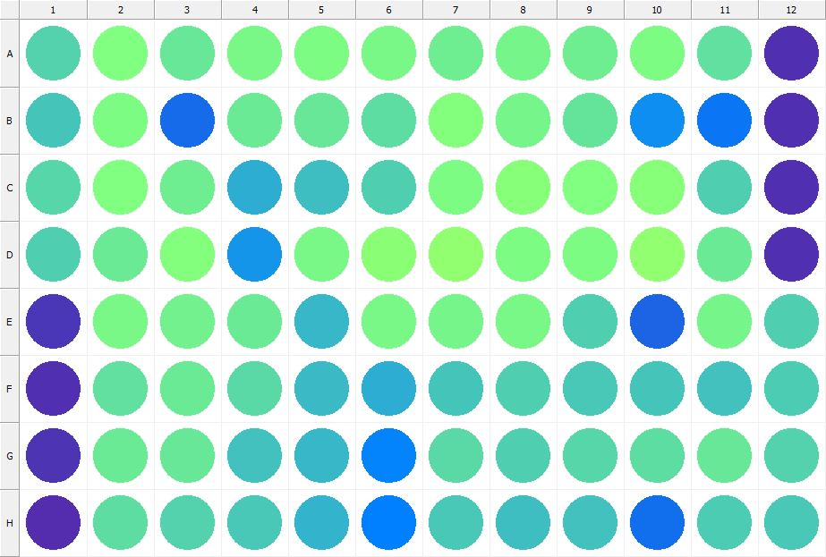

|  |
| --- |
| **Results for Tim_CTB(1) - channel 1 (RFU)** |

|  |  |  |  |  |  |  |  |  |  |  |  |  |
| --- | --- | --- | --- | --- | --- | --- | --- | --- | --- | --- | --- | --- |
|  | 01 | 02 | 03 | 04 | 05 | 06 | 07 | 08 | 09 | 10 | 11 | 12 |
| A | 142346 | 172311 | 155156 | 166105 | 170357 | 166525 | 161174 | 165645 | 160330 | 170224 | 151836 | 31840 |
| B | 132449 | 170255 | 72289 | 156841 | 155504 | 148626 | 173321 | 164681 | 152903 | 96100 | 78177 | 31665 |
| C | 142721 | 171312 | 160966 | 116529 | 126741 | 138618 | 169201 | 176699 | 172460 | 175781 | 138999 | 32406 |
| D | 138751 | 158242 | 173510 | 98976 | 167865 | 179114 | 184178 | 169546 | 168324 | 184166 | 156710 | 32864 |
| E | 37210 | 165903 | 163343 | 158027 | 123054 | 167129 | 165085 | 167376 | 140026 | 66622 | 163911 | 138950 |
| F | 32238 | 150094 | 156607 | 145593 | 125409 | 115073 | 132152 | 138682 | 133982 | 132429 | 128898 | 137690 |
| G | 34603 | 157587 | 155119 | 129569 | 123030 | 87582 | 146969 | 139563 | 144627 | 148623 | 155202 | 141711 |
| H | 31280 | 148488 | 141428 | 134481 | 121511 | 84672 | 134879 | 128090 | 128860 | 73640 | 135907 | 135025 |

|  |  |
| --- | --- |
| **Plate information** | |
|  | |
| **Plate** | 11 |
| **Repeat** | 1 |
| **Barcode** |  |
| **Measured height** | 14.78 |
| **Inside temperature at start** | 23.83 |
| **Inside temperature at end** | 23.83 |
| **Humidity at start** | 14.8 |
| **Humidity at end** | 14.8 |
| **Ambient temperature at start** | 23.73 |
| **Ambient temperature at end** | 23.73 |
| **Group** | 1 |
| **Label** | Tim_CTB(1) |
| **ScanX** | 0 |
| **ScanY** | 0 |
| **Measinfo** | De=1st Ex=Top Em=Top Wdw=N/A (14) |
| **Kinetics** | 0 |
| **Measurement date** | 11/21/2022 1:22:54 PM |
|  | |

|  |
| --- |
| **Background information** |
| Legend:  HDR1 - Plate  HDR2 - Label  HDR3 - Result  HDR4 - Signal  HDR5 - Flashes/Time  HDR6 - Meastime  HDR7 - MeasInfo |
| HDR1 HDR2 HDR3 HDR4 HDR5 HDR6 HDR7  11 Tim_CTB 0 1077 1 00:00:00.000 De=1st Ex=Top Em=Top Wdw=N/A (14) |
|  |

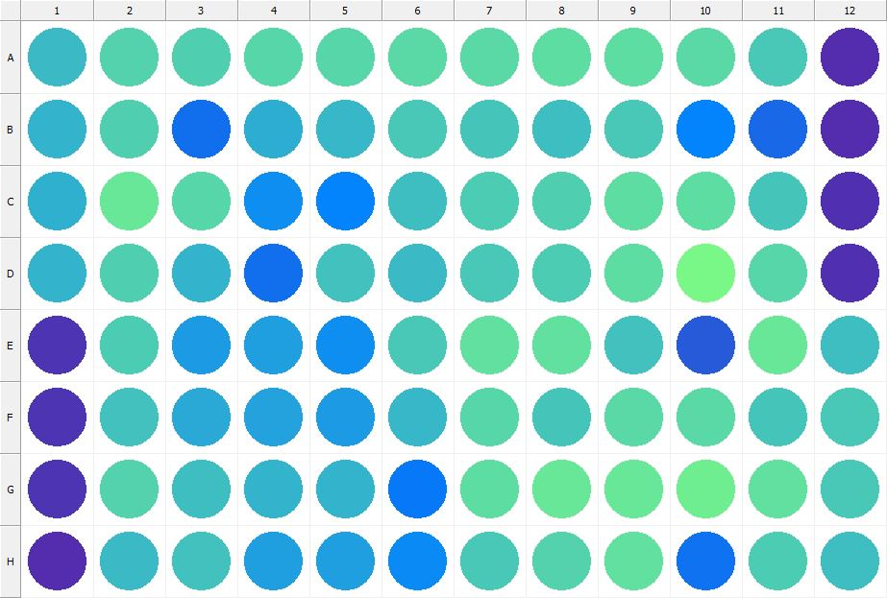

|  |
| --- |
| **Results for Tim_CTB(1) - channel 1 (RFU)** |

|  |  |  |  |  |  |  |  |  |  |  |  |  |
| --- | --- | --- | --- | --- | --- | --- | --- | --- | --- | --- | --- | --- |
|  | 01 | 02 | 03 | 04 | 05 | 06 | 07 | 08 | 09 | 10 | 11 | 12 |
| A | 124781 | 142284 | 138774 | 144408 | 143911 | 145593 | 146752 | 149154 | 148268 | 145299 | 133895 | 31137 |
| B | 119929 | 140225 | 73786 | 115617 | 122310 | 133552 | 133299 | 126576 | 134881 | 87077 | 70573 | 31153 |
| C | 118707 | 156359 | 144628 | 95649 | 87226 | 126608 | 135923 | 139217 | 148308 | 148332 | 131563 | 31654 |
| D | 121243 | 138143 | 119770 | 73341 | 128876 | 125816 | 133785 | 136185 | 149204 | 166393 | 144325 | 32399 |
| E | 34623 | 136895 | 103886 | 107556 | 95256 | 134462 | 151695 | 151046 | 129757 | 60079 | 154418 | 126795 |
| F | 34147 | 129977 | 112583 | 109911 | 104745 | 122364 | 143703 | 132693 | 145305 | 146572 | 133025 | 133469 |
| G | 34306 | 140697 | 128436 | 120178 | 121433 | 82156 | 147833 | 154763 | 154662 | 161075 | 149805 | 135050 |
| H | 30440 | 125528 | 129820 | 106477 | 107054 | 92240 | 135691 | 140619 | 151514 | 76777 | 137645 | 128508 |

|  |  |
| --- | --- |
| **Plate information** | |
|  | |
| **Plate** | 12 |
| **Repeat** | 1 |
| **Barcode** |  |
| **Measured height** | 14.78 |
| **Inside temperature at start** | 23.83 |
| **Inside temperature at end** | 23.83 |
| **Humidity at start** | 14.6 |
| **Humidity at end** | 14.6 |
| **Ambient temperature at start** | 23.93 |
| **Ambient temperature at end** | 23.93 |
| **Group** | 1 |
| **Label** | Tim_CTB(1) |
| **ScanX** | 0 |
| **ScanY** | 0 |
| **Measinfo** | De=1st Ex=Top Em=Top Wdw=N/A (14) |
| **Kinetics** | 0 |
| **Measurement date** | 11/21/2022 1:23:34 PM |
|  | |

|  |
| --- |
| **Background information** |
| Legend:  HDR1 - Plate  HDR2 - Label  HDR3 - Result  HDR4 - Signal  HDR5 - Flashes/Time  HDR6 - Meastime  HDR7 - MeasInfo |
| HDR1 HDR2 HDR3 HDR4 HDR5 HDR6 HDR7  12 Tim_CTB 0 1069 1 00:00:00.000 De=1st Ex=Top Em=Top Wdw=N/A (14) |
|  |

|  |  |
| --- | --- |
|  | |
| **Basic assay information** | |
| **Assay ID** | 24219 |
| **Assay Started** | 11/21/2022 1:15:12 PM |
| **Assay Finished** | 11/21/2022 1:23:47 PM |
| **Assay Exported** | 11/21/2022 1:28:09 PM |
| **Protocol ID** | 100568 |
| **Protocol Name** | Copy of 96well-CTB_Tim |
| **Serial#** | 1020141 |
|  | |
|  | |
|  | |
| **Protocol information** | |
| **Protocol:** | |
| **Protocol name** | Copy of 96well-CTB_Tim |
| **Number of assay repeats** | 1 |
| **Start assay repeat each** | N/A |
| **Number of plate repeats** | 1 |
| **Start plate repeat each** | N/A |
| **Is label meas. height used** | Yes |
| **Height of measurement** | Defined in label |
| **Is gripper height used** | No |
| **Mode of measurement** | By Rows, bi-directional |
| **Rotated plate** | No |
| **Soft move** | No |
| **Protocol notes** |  |
|  | |
| **Plate type:** | |
| **Name of the plate type** | 96 General |
| **Number of rows** | 8 |
| **Number of columns** | 12 |
| **Number of the wells in the plate** | 96 |
| **Height of the plate** | 14.35 mm |
|  | |
| **Coordinates of corners:** | |
| **96 General + Tim_CTB** | |
| 14.38 mm x------------------------------------------------------ x 113.38 mm  11.24 mm 11.24 mm | |
| 14.38 mm x------------------------------------------------------ x 113.38 mm  74.24 mm 74.24 mm | |
|  | |
|  | |

|  |  |
| --- | --- |
| **Platemap:** | |
| **Plate** | 1 |
| **Group** | 1 |
|  | |

|  |  |  |  |  |  |  |  |  |  |  |  |  |
| --- | --- | --- | --- | --- | --- | --- | --- | --- | --- | --- | --- | --- |
|  | **01** | **02** | **03** | **04** | **05** | **06** | **07** | **08** | **09** | **10** | **11** | **12** |
| **A** | - | - | - | - | - | - | - | - | - | - | - | - |
| **B** | - | - | - | - | - | - | - | - | - | - | - | - |
| **C** | - | - | - | - | - | - | - | - | - | - | - | - |
| **D** | - | - | - | - | - | - | - | - | - | - | - | - |
| **E** | - | - | - | - | - | - | - | - | - | - | - | - |
| **F** | - | - | - | - | - | - | - | - | - | - | - | - |
| **G** | - | - | - | - | - | - | - | - | - | - | - | - |
| **H** | - | - | - | - | - | - | - | - | - | - | - | - |

|  |  |
| --- | --- |
|  | |
| **-** | Undefined |
|  | |
|  | |

|  |  |
| --- | --- |
| **Calculations:** | |
| **No calculations.** | |
|  | |
| **Auto export parameters:** | |
| **Export format** | Plate2 |
| **Include basic assay information** | Yes |
| **Place assay information at** | End of file |
| **Include basic plate information** | Yes |
| **Place plate information at** | Beginning of plate |
| **Include protocol information** | Yes |
| **Protocol info level** | Large |
| **Include error and warning information** | Yes |
| **Include background information** | Yes |
| **Add plate number to the file name** | Yes |
| **Each plate to separate file** | No |
| **Field separator to use** | System |
| **File name format** | <DefaultDataFolder>\<Date>\<ProtocolName>_<AssayID>.csv |
|  | |
| **Operations:** | |
| Plate 1  Group 1  Measurement  Label..................................................... Tim_CTB(1) | |
| **Labels:** | |
| **Tim_CTB** | 4000137 |
| **Top mirror** | General |
| **Bottom mirror** | N/A |
| **Exc. filter** | Photometric 530 |
| **Using of excitation filter** | Top |
| **2nd exc. filter** | N/A |
| **Using of 2nd excitation filter** | Top |
| **Ems. filter** | Photometric 590 |
| **2nd ems. filter** | N/A |
| **Measurement height** | 6.5 mm |
| **Number of flashes** | 1 |
| **Number of flashes integrated** | 1 |
| **PMT gain** | 1 |
| **Excitation light** | 100% |
| **Reference excitation light** | 100% |
| **Emission light** | 100% |
| **Reference AD gain** | 4 |
| **Reference signal** | 383728 |
| **Last edited** | 2/11/2019 10:20:00 AM |
| **Last edited by** | EnVision |
| **Factory preset** | No |
|  | |
| **Filters:** | |
| **Photometric 530** | 310 |
| **Filter type** | Excitation |
| **Description** | P530 CWL=530nm BW=8nm Tmin=55% |
| **Used with** | Absorbance,DELFIA - Time-resolved Fluorescence,Fluorescence Intensity,Fluorescence Polarization,LANCE - Time-resolved Fluorescence |
| **Last edited** | 8/19/2014 4:24:21 PM |
| **Last edited by** | Installation |
| **Factory preset** | Yes |
|  | |
| **Photometric 590** | 314 |
| **Filter type** | Excitation |
| **Description** | P590 CWL=590nm BW=8nm Tmin=40% |
| **Used with** | Absorbance,DELFIA - Time-resolved Fluorescence,Fluorescence Intensity,Fluorescence Polarization,LANCE - Time-resolved FluorescenceAbsorbance,DELFIA - Time-resolved Fluorescence,Fluorescence Intensity,Fluorescence Polarization,LANCE - Time-resolved Fluorescence |
| **Last edited** | 8/19/2014 4:24:21 PM |
| **Last edited by** | Installation |
| **Factory preset** | Yes |
|  | |
| **Mirror modules:** | |
| **General** | 401 |
| **Used by** | Top |
| **Dual** | No |
| **Bias** | No |
| **Description** | BS50 |
| **Used with** | Luminescence,DELFIA - Time-resolved Fluorescence,Fluorescence Intensity,Fluorescence Polarization,LANCE - Time-resolved Fluorescence |
| **Last edited** | 8/19/2014 4:24:21 PM |
| **Last edited by** | Installation |
| **Factory preset** | Yes |
|  | |
| **Instrument:** | |
| **Serial number** | 1020141 |
| **Nickname** | EnVision |
|  | |
|  | |
|  | |
|  | |
| **Notifications:** | |
| Assay notifications:  INFO: Assay aborted at plate 12 plate repeat 1 and well H01. There may be missing results | |
|  | |
|  | |

|  |
| --- |
|  |
| **Exported with EnVision Workstation version 1.13.3009.1409** |